## 

## User Requirements

You are required to provide a new ***MVC*** solution to ***manage people***, their ***accounts*** and ***transactions*** logged against these accounts.

OPTIONAL FOR JUNIORS ONLY (**Mandatory for Seniors & Intermediate**):

Please employ SOLID principles for this assessment.

### General

You are required to create an MVC web project with access to the following links:

* Home
* Persons
* About
* Contact

The above links should be displayed automatically as a top menu and have the same appearance and functionality on every page within the website solution. The web site must be well styled and offer a friendly user interface.

OPTIONAL: Design your own logo which can also appear on every web page and always links to the home page. You can create unit tests to test your application logic.

### Home Page

The home page will be a welcome screen with a brief description of what the web site is about.

### About Page

Use the about page to display any information you may feel is relevant to this assessment or to tell us more about yourself.

### Contact Pages

Use the contact page to display your contact information (this information can be fictitious).

OPTIONAL: Your contact page can have working links to email you directly and to your favourite social page (actual links can be fictitious if you prefer, but they must work).

### Persons List Page

The persons list page must provide the following features:

* Display a list of existing persons with links for editing and deleting.
* Effectively find a person or an account by using any of the following criteria:
  + ID Number
  + Surname
  + Account Number
* Allow you to create new persons.
* The navigation map should be similar to the following flow diagram:

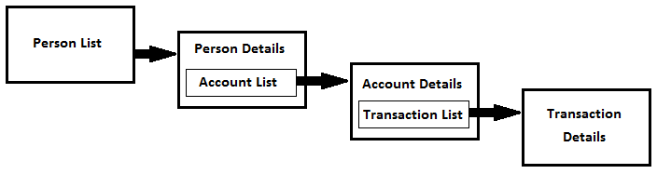

OPTIONAL FOR JUNIORS ONLY (**Mandatory for Seniors & Intermediate**):

The persons list must include paging with a maximum of 10 persons per page.

### Person Details

The person details page will be used to capture a person’s details. It must have the following features:

* Allow the user to change and save the person information.
* Provision to add new accounts.
* Display a list of existing accounts for the person with a link for editing.

### Account Details

The account details page will be used to capture account details. It should include the following features:

* Allow the user to change and save the account information.
* Add new transactions.
* Display a list of existing transactions for the account with a link for editing.

OPTIONAL FOR JUNIORS ONLY (**Mandatory for Seniors & Intermediate**):

Provision must be made to close an account or to re-open it.

### Transaction Details

The transaction details page will be where transactions can be captured. It must have the following features:

* Allow the user to change and save the transaction information.
* You must use a DatePicker for the Transaction Date.
* The transaction capture date must be updated whenever it is created or edited.

## Validation and Business Rules

All user input must be fully validated according to data types and database specification. In addition, the following must also be applied:

**Persons**

* A person can only be created once with the same ID Number.
* A person can have an unlimited number of accounts.
* Only persons with no accounts or where all accounts are closed may be deleted.

**Accounts**

* You cannot have duplicated account numbers.
* New accounts can only be added after the person is created (not while it is being created).
* The user is never allowed to change the account outstanding balance.
* An account may have an unlimited number of transactions.
* The outstanding balance for the account must be updated whenever a new transaction is added or when the amount for an existing transaction is modified.
* If applicable, you cannot close an account when the balance is not zero.
* If applicable, no transactions may be posted to closed accounts.

**Transactions**

* The transaction date can never be in the future.
* New transactions can only be added after the account is created (not while it is being created).
* The user is never allowed to change the capture date.
* Users may enter debit or credit amounts for a transaction.
* The transaction amount can never be zero (0).

## Database Requirements

Create a new SQL database using any version of Microsoft SQL Server or Server Express >= 2005. Use the attached script to create 3 tables (Persons, Accounts and Transactions) and populate those tables with sample data.

